**ASEAN DAY: FLAG HOISTING CEREMONY 2025**

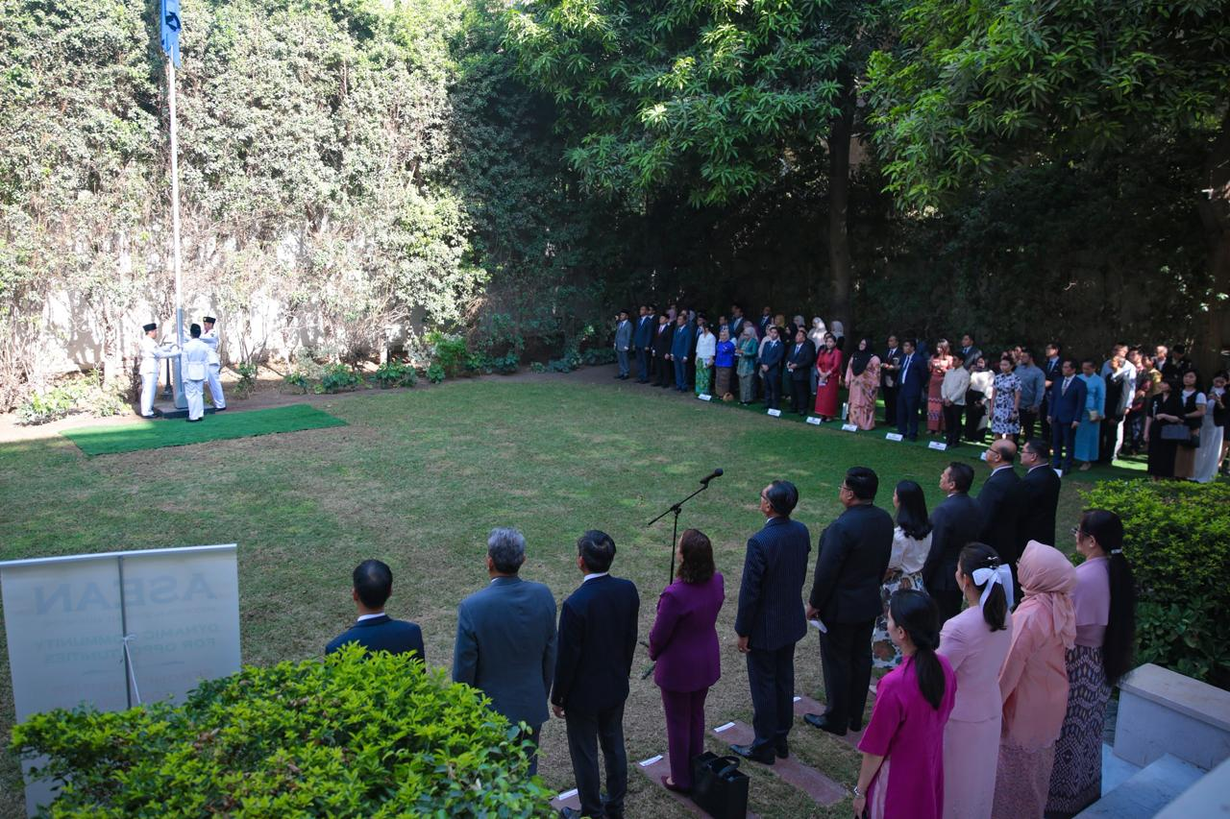

1. On 20 August 2025, the ASEAN Committee in Cairo held a flag hoisting ceremony in conjunction with ASEAN Day.
2. 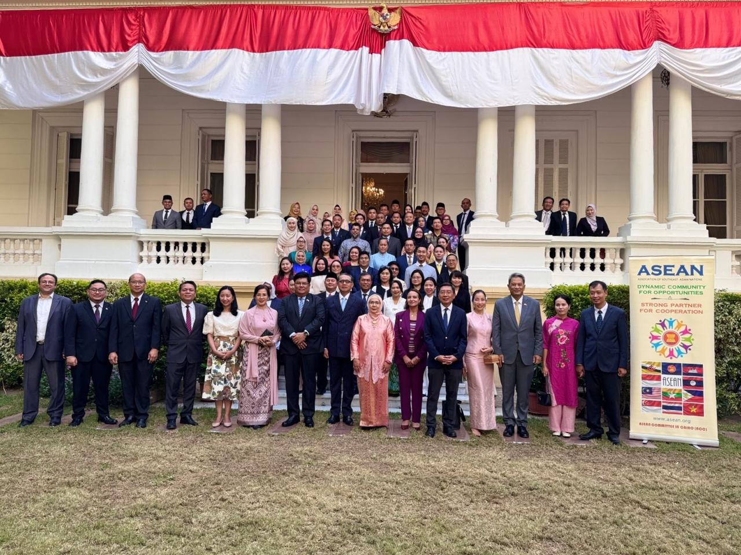The event was held at the Residence of Indonesian Ambassador in Cairo.
3. All ASEAN Head of Missions (HoMs) and Chargé d’Affaires in Egypt attended the event.

******